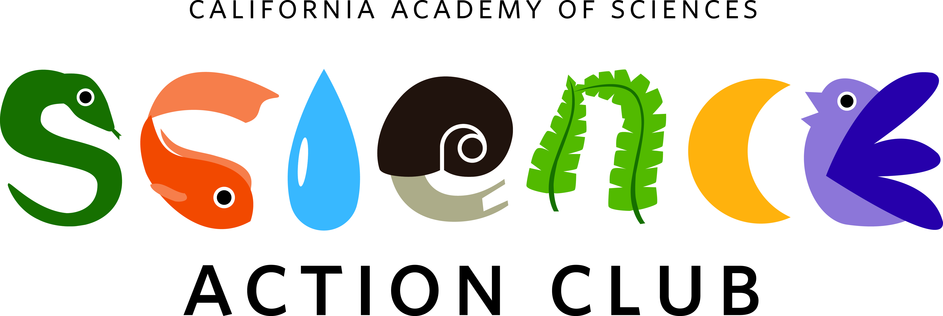

**Science Action Club**

**Application Preview 2017-2018**

**Application deadline: Monday, February 26, 2018**

*Questions? Contact* *Christi Whitworth at* [*cwhitworth@pari.edu*](mailto:cwhitworth@pari.edu)

*Thank you for your interest in Science Action Club. This document is NOT the application form. The actual application form will be available through the application link at the bottom of this page. We encourage you to use this document to draft your responses in advance. If you have questions about the application,* please contact *Christi Whitworth at* [*cwhitworth@pari.edu*](mailto:cwhitworth@pari.edu).

**About Science Action Club**

Founded in 2011 by the California Academy of Sciences in San Francisco, Science Action Club (SAC) is a nationwide program for middle school youth in out-of-school time, designed to transform environmental education at scale. Through games, projects, and hands-on citizen science, youth in SAC investigate nature, document their discoveries, connect with scientists, and design strategies to protect our planet. Educators receive professional development training on SAC kits, guidebooks, and best practices for teaching science in the informal learning environment.

In 2016-2017, SAC engaged 15,000 youth and 1,600 educators through 750 clubs and 215 cities in 17 states across the country. Learn more about the growing SAC network by visiting [www.calacademy.org/sac](http://www.calacademy.org/sac)

**What’s Included**

SAC features three environmental science units that spark curiosity and wonder, build scientific skills, and help youth develop STEM identities. Each unit includes a guidebook with 12 fun activities that take youth outside to connect with nature and contribute to meaningful science research. Each activity is designed for a 60-90-minute club session and can be extended with bonus resources. Teaching kits include class sets of science tools and supplies, and educators participate in blended learning professional development, including an interactive online training, a face-to-face workshop, and digital access to the SAC Educator Portal.

**SAC Curriculum**

***Bug Safari***explores small creatures with big environmental impacts. On local field expeditions, youth search for bugs, collect specimens, and post photographs to iNaturalist—a citizen science project and online social network for nature research. Working with scientists and other students, youth identify arthropod species and document habitat conditions that influence our planet’s health.

***Bird Scouts***explores feathers, flight, and the features that make birds unique. Using tools and technology, youth identify local species and investigate environmental changes that impact bird behavior. The checklists youth submit to eBird—a citizen science project from the Cornell Lab of Ornithology—help scientists track changes in bird distribution and abundance across the globe.

***Cloud Quest***explores the impact of clouds on weather and climate. Using the GLOBE Observer citizen science platform, youth identify sky conditions and report their discoveries to NASA. Researchers map these observations against satellite image data to study how clouds influence the flow of energy through Earth’s atmosphere.

**Application Instructions**

Programs that wish to participate in SAC may apply for one or two curriculum units per school year. Applications are due Monday, February 26, 2018. To [apply](https://docs.google.com/forms/d/e/1FAIpQLScMNGx69PiQfHtI_xmFZDrinvnlVjWkABOtuZWhOOUrx1eHfg/viewform?usp=sf_link), you must complete the application form online.

This application should be filled out by a Program Coordinator or Program Director. It will take approximately 20 minutes to complete—please plan accordingly. You will need to submit one application for each program location you wish to enroll.

[Click here to access the SAC program application](https://docs.google.com/forms/d/e/1FAIpQLScMNGx69PiQfHtI_xmFZDrinvnlVjWkABOtuZWhOOUrx1eHfg/viewform?usp=sf_link)

**Application Acceptance**

If accepted, your program will be required to register for the Activity Leader Training and pay a registration fee of $25 per trainer.*

*Each SAC unit includes:*

* *one online training*
* *one hands-on training workshop at Greensboro Science Center on March 10, 2018.*
* *one teaching kit*
* *one guidebook*
* *access to the SAC Educator Portal*
* *ongoing support from Christi and Mike*

*\*Scholarships are available. The Science Action Club program is highly subsidized by grant funding, thanks to SAC’s generous donors.*

**Program Commitments**

If accepted, your program will be expected to:

* Recruit at least 15 youth in grades 5-8 to participate in SAC.
* Identify 1-2 reliable program staff to lead SAC with youth.
* Ensure the program leader(s) and one additional staff person complete the online training and attend the training workshop.
* Implement all 12 SAC activities per unit during the 2017-2018 school year.
* Provide reliable Internet access and at least one mobile device per club. Projectors, speakers, and additional mobile devices are strongly recommended.
* Conduct citizen science and report observations (Internet access required).
* Track youth attendance and participate in program evaluation activities.

If you anticipate any challenges or barriers to participating in Science Action Club, please contact *Christi Whitworth at* [*cwhitworth@pari.edu*](mailto:cwhitworth@pari.edu) to discuss. Some common challenges may include:

* I don’t think my program will be able to attend the training.
* I don’t think my program will be able to recruit enough youth or maintain high attendance.
* My program does not have reliable Internet access or digital technology.

**This form is designed to help applicants prepare their responses before starting the online application and only provides partial questions. DO NOT submit this form as your application. Remember: you will need to submit one application for each program location you wish to enroll.**

**Part I. Eligibility**

If accepted, your program will be committing to meet the program commitments outlined. If you are unable to meet any of these, please explain why (contact *Christi Whitworth at* [*cwhitworth@pari.edu*](mailto:cwhitworth@pari.edu)before proceeding).

**Part II. Agency Information**

The agency is the organization that oversees the program where Science Action Club will be offered.

* Name of agency
* Mailing address
* City
* ZIP code
* Phone number
* Website
* Agency contact name
* Position or title
* Phone number
* Email address
* Agency type (select all that apply)
  + 4-H Council
  + Boys & Girls Club
  + Community-based organization
  + Faith-based organization
  + Licensed family child care
  + Parks and recreation
  + School-based afterschool (public and/or private funding)
  + School-based child/school-age care (public and/or private funding)
  + YMCA
  + Other (please indicate)
* Does your agency receive ASES Supplemental or 21st CCLC funding?
* What other sources of funding does your agency receive? (select all that apply)
  + City or County
  + Individual Donors
  + Parent Fees
  + Private Foundation
  + Title 1/Migrant Education
  + Title 3/EL and Immigrant Student Programs
  + None
  + Other (please indicate)
* Will your organization need assistance with the Activity Leader Training Registration Fee?
* Will your organization need support for travel to the training?
* How many program locations would you like to enroll in SAC? If more than one, you will need to submit an additional application.

**Part III. Program Information**

* Program location name
* Address
* City
* ZIP code
* School district
* Total number of youth served at this program location
  + 0-20
  + 21-50
  + 51-100
  + 101-200
  + 201+
  + Other (please indicate)
* What percentage of youth qualify for free or reduced lunch?
* Which grades does your program serve?
* Which grades will participate in Science Action Club? Select all that apply. If you select other, please specify.
  + 5
  + 6
  + 7
  + 8
  + Other (please indicate)
* Would SAC be voluntary or required for youth? Please explain.

**Part IV. Activity Leader Information**

The activity leader is the program staff who will facilitate Science Action Club with youth.

* Activity leader name
* Position or title
* Phone number
* Email address

If you do not know who will lead SAC, when will you expect to know that information? (please communicate that information with Christi as soon as you know)

* Supervisor’s name (who will supervise the activity leader)?
* Supervisor’s title
* Phone number
* Email address

**Part VI. Interest and Capacity**

* Please respond honestly and briefly to the following questions, using 1-3 sentences.
  + Why are you interested in Science Action Club?
  + Do you anticipate any challenges to implementing Science Action Club? Please explain.
  + How will you ensure that staff complete the required SAC trainings? Will staff be compensated for their time? Will you support their travel?
  + What else would you like us to know?